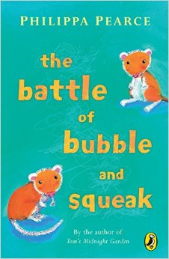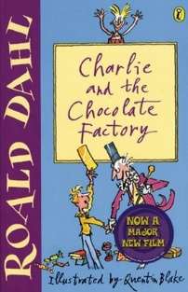**100 Books To Read In Year 3 and 4**

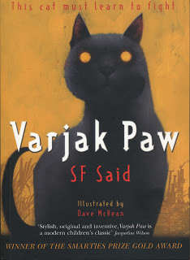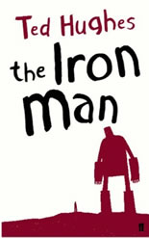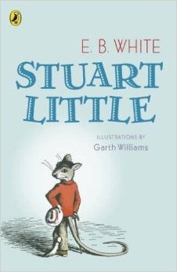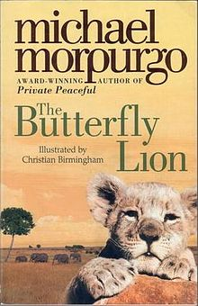

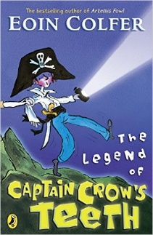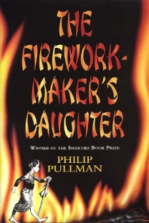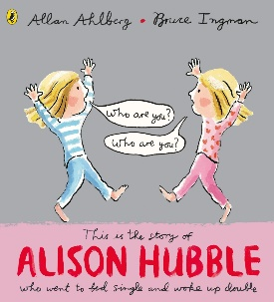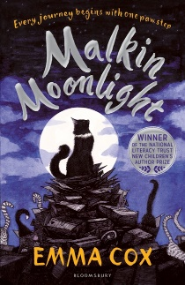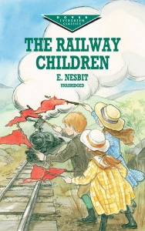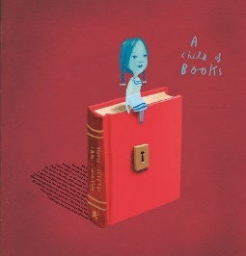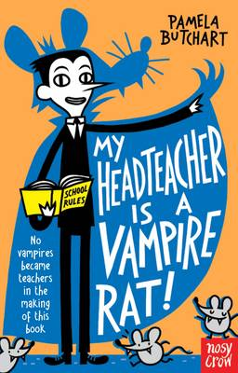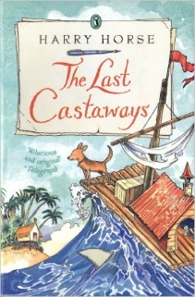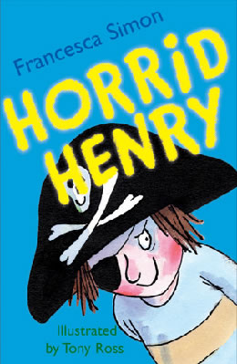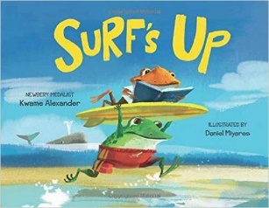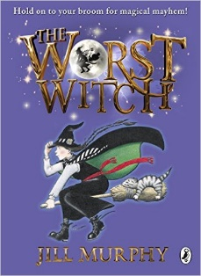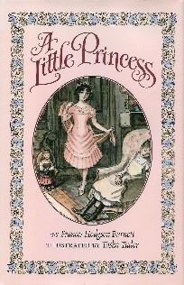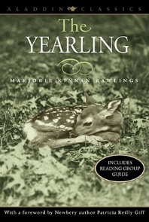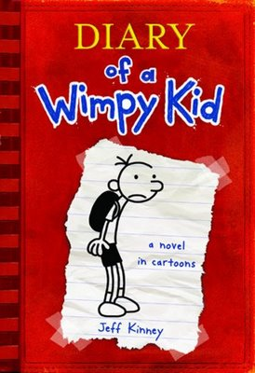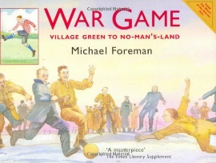

The Legend of Captain Crow’s Teeth

Eoin Colfer

The Firework-Maker’s Daughter

Phillip Pullman

The Battle of Bubble and Squeak

Phillips Pearce

Alison Hubble

Allan Ahlberg and Bruce Ingham

Malkin Moonlight

Emma Cox

The Railway Children

E Nesbit

Varjak Paw

S F Said

A Child Of Books

Oliver Jeffers

My Headteacher is a Vampire Rat

Pamela Butchart

The Last Castaways

Harry Horse

Charlie and the Chocolate Factory  
Roald Dahl

Horrid Henry

Francesca Simon

Surf’s Up

Kwame Alexander

The Worst Witch

Jill Murphy

War Game

Michael Foreman

The Iron Man

Ted Hughes

A Little Princess

Frances Hodgson Burnett

The Yearling

Marjorie Kinnan Rawlings

Diary Of A Wimp Kid

Jeff Kinney

Stuart Little

E B White

The Butterfly Lion

Michael Morpurgo