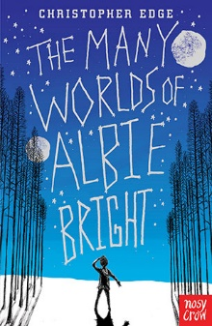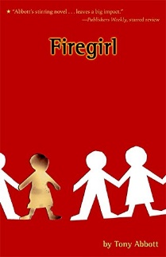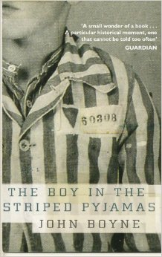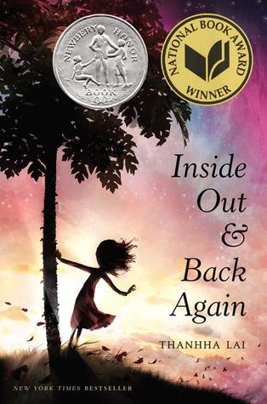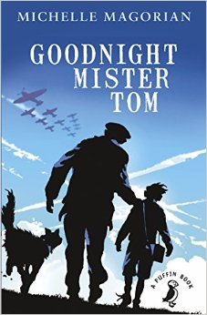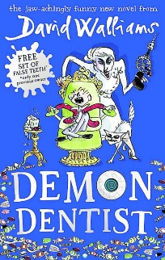**100 Books To Read In Year 5 and 6**

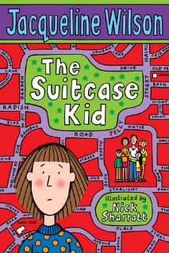

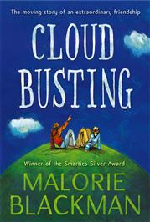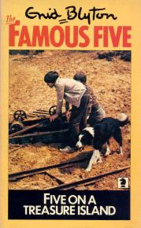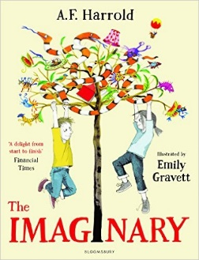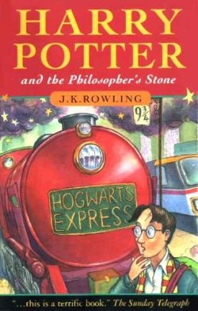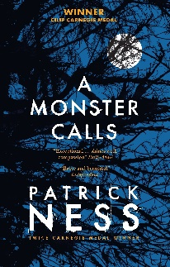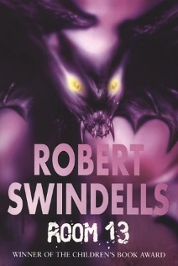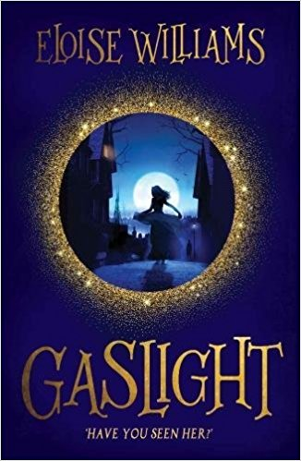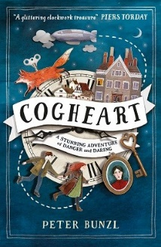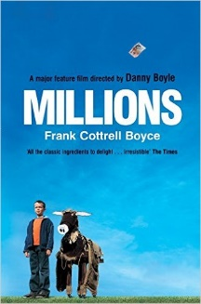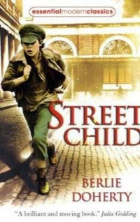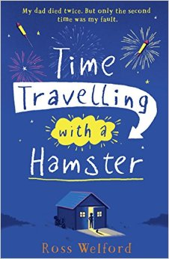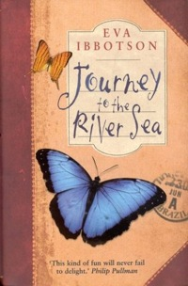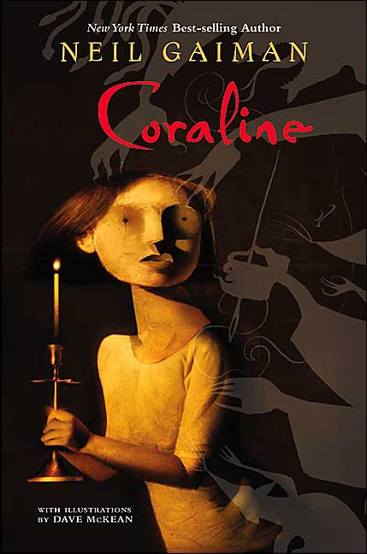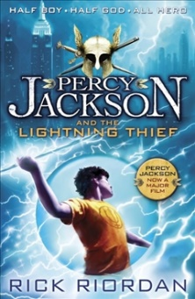v

Cloud Busting

Malorie Blackman

Five On A Treasure Island

Enid Blyton

The Suitcase Kid

Jacqueline Wilson

The Imaginary

A F Harold

Harry Potter and the Philosopher’s Stone

JK Rowling

A Monster Calls  
Patrick Ness

Room 13

Robert Swindells

The Many Worlds of Albie Bright

Christopher Edge

Firegirl

Tony Abbott

Gaslight

Eloise Williams

Cogheart

Peter Bunzl

Street Child

Berlie Doherty

Millions

Frank Cottrell-Boyce

Time Travelling With a Hamster

Ross Welford

The Boy in the Striped Pajamas

John Boyne

Percy Jackson and the Lightning Thief

Rick Riordan

Coraline

Neil Gaiman

Journey to the River Sea

Eva Ibbotson

Inside Out and Back Again

Thannha Lai

Goodnight Mister Tom

Michelle Magorian

Demon Dentist

David Walliams